Game Design Document

Fill up the Following document

1. Write the title of your project.

Answer: The Flappy Bird.

1. What is the goal of the game?

Answer: The goal of this game is to score as much score as possible by using space key to make the bird fly from in between the pipes without touching it.

3. Write a brief story of your game?

Answer: The flappy bird is very hungry and wants food which is far away from it. To reach the food, it needs to cross the magical pipes. If it touches the pipe, then it will have to start from the beginning. Help it reach the food by crossing the pipes without touching it.

4. Which are the playing characters of this game?

* Playing characters are the ones which respond to the user based on the input from the user
* Cars, monkeys, dinos, wizards etc, are the playing characters in the game.

|  |  |  |
| --- | --- | --- |
| Number | Character Name | What can this character do? |
| 1 | Flappy Bird | It will go up if you press the space key. |

5. Which are the Non Playing Characters of this game?

* Non Playing characters are the ones which don't have an action or a behaviour when the user interacts with the game.
* Hurdles, stones, bananas, coins, etc are non playing characters in the game.

|  |  |  |
| --- | --- | --- |
| Number | Character Name | What can this character do? |
| 1 | Pipe | If the Flappy bird touches the pipe, the Flappy bird falls down and the game will restart with Score=0. |

6. Draw your imagination of this game. What does this game look like?

* Draw the game either on your computer or on paper,
* Add images of scenes of the game to show each of the playing and non-playing characters at least once.

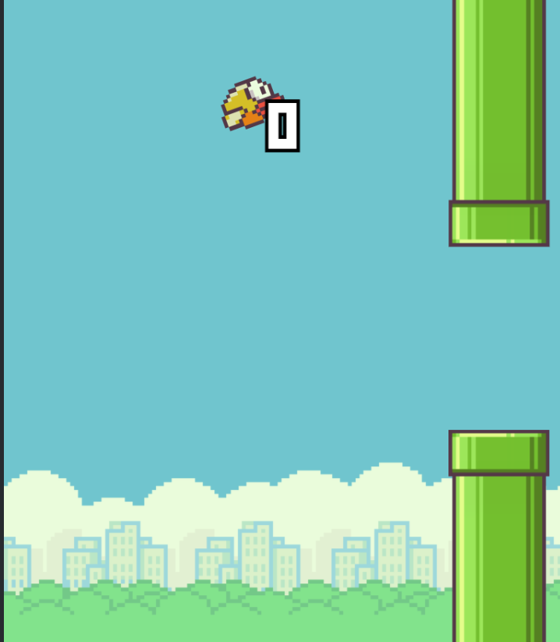

7. How do you plan to make your game engaging?

Answer: I will try to make my game engaging by adding a scoring system which will keep the player engaged to make more and more score.